**SDF TUTORIAL 9**

**Q1.a)**

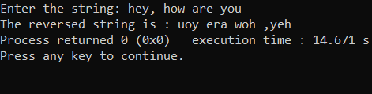#include<stdio.h>

#include<string.h>

int main()

{

int n,i;

char a[100];

printf("Enter the string: ");

gets(a);

n=strlen(a);

printf("The reversed string is : ");

for(i=n-1;i>=0;i--)

{

printf("%c",a[i]);

}

return 0;

}

**b)**

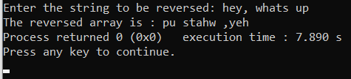#include<stdio.h>

#include<string.h>

int main()

{

int n,i,j;

char a[100];

printf("Enter the string to be reversed: ");

gets(a);

n=strlen(a);

int b[n];

for(i=0,j=n-1;i<n;i++,j--)

{

b[j]=a[i];

}

printf("The reversed array is : ");

for(i=0;i<n;i++)

{

printf("%c",b[i]);

}

return 0;

}

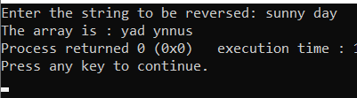**c)**

#include<stdio.h>

#include<string.h>

int main()

{

int n,i,j;

char a[100];

printf("Enter the string to be reversed: ");

gets(a);

n=strlen(a);

for(i=0,j=n-1;i<j;i++,j--)

{

int t;

t=a[j];

a[j]=a[i];

a[i]=t;

}

printf("The array is : ");

for(i=0;i<n;i++)

{

printf("%c",a[i]);

}

return 0;

}

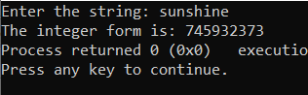**Q2.**

#include<stdio.h>

#include<string.h>

int main()

{

int n,i;

char a[50];

printf("Enter the string: ");

gets(a);

n=strlen(a);

int k=0;

for(i=0;i<n;i++)

{

k=(k*10)+(a[i]-48);

}

printf("The integer form is: %d",k);

return 0;

}

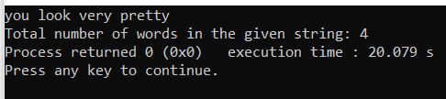Q3.

a. #include <stdio.h>

#include <string.h>

int main()

{

char sentence[50]=”you look very pretty”;

int wordCount = 1;

puts(sentence);

for(int i = 0; i < strlen(sentence)-1; i++)

{

if(sentence[i] == ' ' && isalpha(sentence[i+1]) && (i > 0))

{

wordCount++;

}

}

printf("Total number of words in the string: %d", wordCount);

return 0;

}

b. #include <stdio.h>

#include <string.h>

int main()

{

char sentence[50]=”hey , how are you doing ?”;

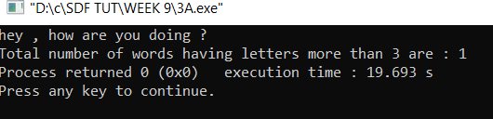 int wordCount=0,letter=0;

puts(sentence);

for(int i = 0;sentence[i]!='\0'; i++)

{

if(sentence[i] == ' ' )

{

if (letter>3)

wordCount++;

letter=0;

}

else letter++;

}

printf("Total number of words having letters more than 3 are : %d", wordCount);

return 0;

}

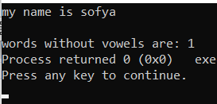c. #include<stdio.h>

#include<stdlib.h>

int main()

{

char ch[50]=”my name is sofya”;

int i=0,j=0,flag;

puts(ch);

while(ch[i]!='\0')

{

flag=1;

while(ch[i]!=' '&& flag==1 && ch[i]!='\0')

{

if(ch[i]=='a'|| ch[i]=='e' ||ch[i]=='i'|| ch[i]=='o' ||ch[i]=='u')

{

flag=0;

while(ch[i]!=' ' && ch[i]!='\0')

{

i++;

}

i--;

}

i++;

}

if(flag==1)

{

j++;

}

if( ch[i]=='\0')

{

break;

}

i++;

}

printf("\nwords without vowels are: %d",j);

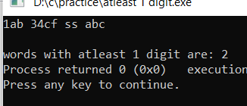}

d. #include<stdio.h>

#include<stdlib.h>

int main()

{

char ch[50]=”1ab 34cf ss abc”;

int i=0,j=0,flag;

puts(ch);

while(ch[i]!='\0')

{

flag=1;

while(ch[i]!=' '&& flag==1 && ch[i]!='\0')

{

if(ch[i]>47 && ch[i]<58)

{

flag=0;

while(ch[i]!=' ' && ch[i]!='\0')

{

i++;

}

i--;

}

i++;

}

if(flag==0)

{

j++;

}

if( ch[i]=='\0')

{

break;

}

i++;

}

printf("\nwords with atleast 1 digit are: %d",j);

}

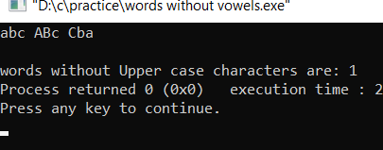e. #include<stdio.h>

#include<stdlib.h>

int main()

{

char ch[50]=”abc ABc Cba”;

int i=0,j=0,flag;

puts(ch);

while(ch[i]!='\0')

{

flag=1;

while(ch[i]!=' '&& flag==1 && ch[i]!='\0')

{

if(ch[i]>=64 && ch[i]<=91)

{

flag=0;

while(ch[i]!=' ' && ch[i]!='\0')

{

i++;

}

i--;

}

i++;

}

if(flag==1)

{

j++;

}

if( ch[i]=='\0')

{

break;

}

i++;

}

printf("\nwords without Upper case characters are: %d",j);

}

f. #include <stdio.h>

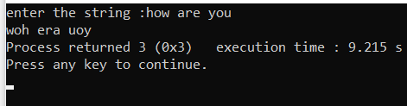#include <string.h>

void main()

{

int i, j = 0, k = 0, x, len;

char str[100], str1[10][20], temp;

printf("enter the string :");

gets(str);

for (i = 0;str[i] != '\0'; i++)

{

if (str[i] == ' ')

{

str1[k][j]='\0';

k++;

j=0;

}

else

{

str1[k][j]=str[i];

j++;

}

}

str1[k][j] = '\0';

/* reverses each word of a given string */

for (i = 0;i <= k;i++)

{

len = strlen(str1[i]);

for (j = 0, x = len - 1;j < x;j++,x--)

{

temp = str1[i][j];

str1[i][j] = str1[i][x];

str1[i][x] = temp;

}

}

for (i = 0;i <= k;i++)

{

printf("%s ", str1[i]);

}

}

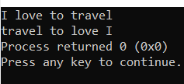g. int main()

{

char str[50]=”I love to travel”;

int length,i;

puts(str);

// Traverse string from end

length = strlen(str);

for (i = length - 1; i >= 0; i--) {

if (str[i] == ' ') {

str[i] = '\0';

// Start from next charatcer

printf("%s ", &(str[i]) + 1);

}

}

// printing the last word

printf("%s", str);

return 0;

}

Q4.

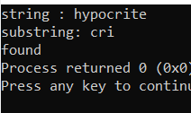#include<stdio.h>

int main()

{

char a[20]="hypocrite",b[20]="cri",c=0,i=0,j;

printf("string : %s\n",a);

printf("substring: %s\n",b);

while(a[i]!='\0')

{

j=0;

while (b[j]==a[i]) //to find substring

{

j++;

i++;

if(b[j]=='\0') //substring found

{

c=0;

break;

}

else

c=1;

}

if(c==0)

break;

i-=(j);

i++;

}

if(c==0)

printf("found");

else

printf("not found");

}

Q5.

a.#include<stdio.h>

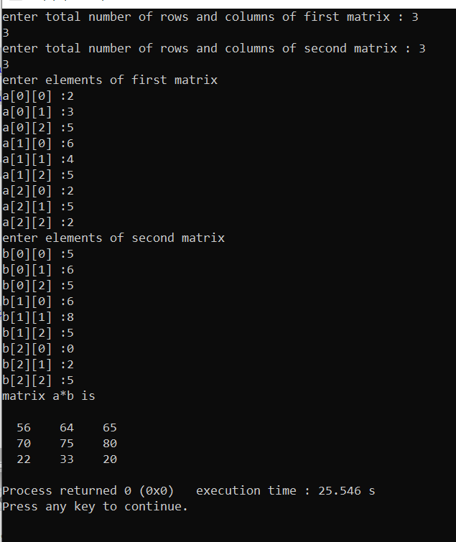#include<stdlib.h>

int main()

{

int r1,r2,c1,c2,a[10][10],b[10][10],c[10][10];

printf("enter total number of rows and columns of first matrix : ");

scanf("%d%d",&r1,&c1);

printf("enter total number of rows and columns of second matrix : ");

scanf("%d%d",&r2,&c2);

if(c1==r2)

{

printf("enter elements of first matrix \n");

for(int i=0;i<r1;i++)

{

for(int j=0;j<c1;j++)

{

printf("a[%d][%d] :",i,j);

scanf("%d",&a[i][j]);

}

}

printf("enter elements of second matrix \n");

for(int i=0;i<r2;i++)

{

for(int j=0;j<c2;j++)

{

printf("b[%d][%d] :",i,j);

scanf("%d",&b[i][j]);

}

}

for(int i=0;i<r1;i++)

{

for(int j=0;j<c2;j++)

{

c[i][j]=0;

for(int k=0;k<c1;k++)

{

c[i][j]+=a[k][j]*b[i][k];

}

}

}

printf("matrix a*b is \n\n");

for(int i=0;i<r2;i++)

{

for(int j=0;j<c1;j++)

{

printf(" %d ",c[i][j]);

}

printf("\n");

}

}

else printf("wrong input");

}

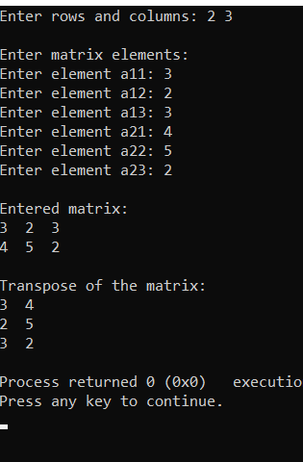b. #include <stdio.h>

int main() {

int a[10][10], transpose[10][10], r, c, i, j;

printf("Enter rows and columns: ");

scanf("%d %d", &r, &c);

printf("\nEnter matrix elements:\n");

for (i = 0; i < r; ++i)

for (j = 0; j < c; ++j) {

printf("Enter element a%d%d: ", i + 1, j + 1);

scanf("%d", &a[i][j]);

}

printf("\nEntered matrix: \n");

for (i = 0; i < r; ++i)

for (j = 0; j < c; ++j) {

printf("%d ", a[i][j]);

if (j == c - 1)

printf("\n");

}

// Finding the transpose of matrix a

for (i = 0; i < r; ++i)

for (j = 0; j < c; ++j) {

transpose[j][i] = a[i][j];

}

// Displaying the transpose of matrix a

printf("\nTranspose of the matrix:\n");

for (i = 0; i < c; ++i)

for (j = 0; j < r; ++j) {

printf("%d ", transpose[i][j]);

if (j == r - 1)

printf("\n");

}

return 0;

}

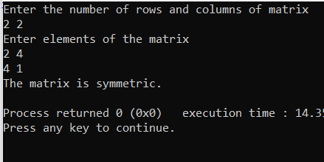Q6. #include<stdio.h>

int main()

{

int m, n, c, d, matrix[10][10], transpose[10][10];

printf("Enter the number of rows and columns of matrix\n");

scanf("%d%d", &m, &n);

printf("Enter elements of the matrix\n");

for (c = 0; c < m; c++)

for (d = 0; d < n; d++)

scanf("%d", &matrix[c][d]);

for (c = 0; c < m; c++)

for (d = 0; d < n; d++)

transpose[d][c] = matrix[c][d];

if (m == n) /* check if order is same */

{

for (c = 0; c < m; c++)

{

for (d = 0; d < m; d++)

{

if (matrix[c][d] != transpose[c][d])

break;

}

if (d != m)

break;

}

if (c == m)

printf("The matrix is symmetric.\n");

else

printf("The matrix isn't symmetric.\n");

}

else

printf("The matrix isn't symmetric.\n");

return 0;

}

b.

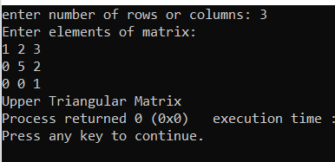#include <stdio.h>

int main()

{

int n;

printf("enter number of rows or columns: ");

scanf("%d",&n);

int flag = 0;

int mat[n][n];

int i, j;

printf("Enter elements of matrix: \n");

for(i = 0; i < n; i++)

{

for(j = 0; j < n; j++)

scanf("%d",&mat[i][j]);

}

for (i = 1; i < n; i++)

for (j = 0; j < i; j++)

if (mat[i][j] != 0)

flag = 0;

else

flag = 1;

if (flag == 1)

printf("Upper Triangular Matrix");

else

printf("Not an Upper Triangular Matrix");

return 0;

}

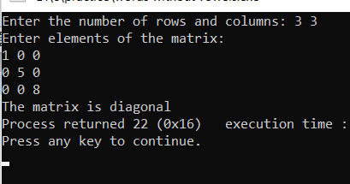c. #include <stdio.h>

#include <conio.h>

void main()

{

int x[10][10], nr, nc, r, c, flag ;

printf("Enter the number of rows and columns: ") ;

scanf("%d %d", &nr, &nc) ;

if(nr==nc) /* checking for square matrix */

{

printf("Enter elements of the matrix:\n") ;

for(r=0 ; r<nr ; r++)

for(c=0 ; c<nc ; c++)

scanf("%d", &x[r][c]) ;

flag=1 ;

for(r=0 ; r<nr ; r++)

for(c=0 ; c<nc ; c++)

if(r==c)/* true for diagonal elements */

{

if(x[r][c]==0)

flag=0;

}

else

{

if(x[r][c]!=0)

flag=0;

}

if(flag==1)

printf("The matrix is diagonal") ;

else

printf("The matrix is not diagonal") ;

}

else

printf("The matrix is not a sqaure matrix") ;

}

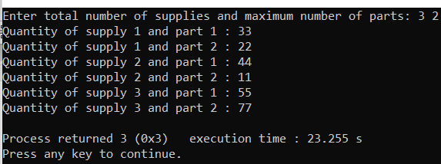Q7.

a. #include <stdio.h>

#include <conio.h>

void main()

{

int x[10][10], nr, nc;

printf("Enter total number of supplies and maximum number of parts: ") ;

scanf("%d%d",&nr,&nc) ;

for(int i=1;i<=nr;i++)

{

for(int j=1;j<=nc;j++)

{

printf("Quantity of supply %d and part %d : ",i,j);

scanf("%d",&x[i][j]);

}

}

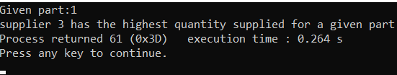}

b. #include <stdio.h>

#include <conio.h>

void main()

{

int x[3][2]={33,22,44,11,55,77}, nr=3, nc=2,num,max;

printf("Given part:1\n");

max=x[0][0];

for(int j=1;j<=2;j++)

{

if(x[j][0]>max)

{

max=x[j][0];

num=j;

}

}

printf("supplier %d has the highest quantity supplied for a given part",num+1);

}

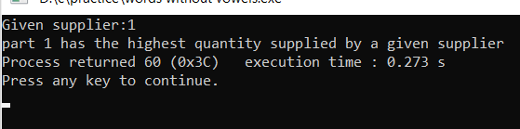c. #include <stdio.h>

#include <conio.h>

void main()

{

int x[3][2]={33,22,44,11,55,77}, nr=3, nc=2,num,max;

printf("Given supplier:1\n");

max=x[0][0];

for(int j=0;j<2;j++)

{

if(x[0][j]>max)

{

max=x[0][j];

num=j;

}

}

printf("part %d has the highest quantity supplied by a given supplier",num+1);

}

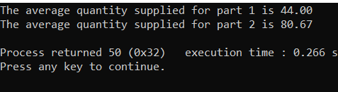d. #include <stdio.h>

#include <conio.h>

void main()

{

int x[3][2]={33,22,44,11,55,77}, nr=3, nc=2,avg=0;

for(int i=0;i<2;i++)

{

for(int j=0;j<3;j++)

{

avg+=x[j][i];

}

printf("The average quantity supplied for part %d is %0.2f\n",i+1,(float)avg/3);

}

}

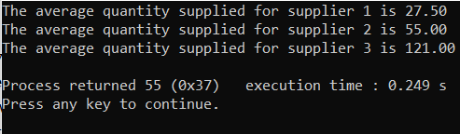e. #include <stdio.h>

#include <conio.h>

void main()

{

int x[3][2]={33,22,44,11,55,77}, nr=3, nc=2,avg=0;

for(int i=0;i<3;i++)

{

for(int j=0;j<2;j++)

{

avg+=x[i][j];

}

printf("The average quantity supplied for supplier %d is %0.2f\n",i+1,(float)avg/2);

}

}